

**A**

**PROJECT REPORT**

**ON**

**“CANTEEN MANAGEMENT SYSTEM”**

**BACHELOR OF BUSINESS ADMINISTRATION**

**(COMPUTER APPLICATION)**

**SEM IV**

**2023-2024**

**SUBMITTED TO**

**Savitribai Phule Pune University**

**DEVELOPED BY**

VIVEK PATIL

SHRINATH BHENDI

**UNDER THE GUIDENCE OF**

**HOD: ASHA MANE**

Annasaheb Magar College Hadapsar Pune-411028.

DEPARTMENT of B.B.A.(C.A)



**CERTIFICATE**

This is certify that Mr. Vivek Patil & Mr. Shrinath Bhendi student of Bachelors Of Business Administration Computer Application has satisfactory completed the project work on “College Canteen Management System” as per the syllabus laid down by the Savitribai Phule Pune University during the academic year 2023-2024

Date:-

Exam seat no Exam seat no

Project In-charge Head of Department

Internal Examiner External Examiner

**ACKNOWLEDGEMENT**

I would want to convey my heartfelt gratitude to Prof. Asha Mane , my mentor, for her invaluable advice and assistance in completing our project.

She was there to assist me every step of the way, and her motivation is what enabled us to accomplish our task effectively.

We would also like to thank all of the other supporting personnel who assisted us by supplying the equipment that was essential and vital, without which we would not have been able to perform efficiently on this project.

PATIL VIVEK

BHENDI SHRINATH

**INDEX**

|  |  |  |
| --- | --- | --- |
| **Chapter**  **No.** | **Particular Name** | **Page No.** |
| **1.** | **Introduction:-** | 5 |
|  | 1.1 Introduction Of System | 6 |
|  | 1.2 Scope Of System | 7 |
|  | 1.3 Propose Of The System | 8 |
| **2.** | **System Analysis:-** | 9 |
|  | 2.1 Feasibility Study | 9 |
|  | 2.2 Fact Finding Technique | 10 |
|  | 2.3Hardware and software Requirement | 7 |
| **3.** | **System Design:-** | 8 |
|  | 3.1 ERD | 9 |
|  | 3.2 DFD | 10 |
|  | 3.3 File Design | 11 |
|  | 3.4 Data dictionary | 12 |
| **4** | **Forms And Report** | 13 |
| **5** | **Testing** | 14 |
| **6** | **Advantages & Limitation** | 15 |
| **7** | **Conclusion** | 16 |
| **8** | **Limitation** | 17 |
| **9** | **Future Enhancement** | 18 |
| **10** | **References** | 18 |

1. **INTRODUCTION**

College Canteen management system is to provide fast services to their college students, Staffs etc.

Usually, People have to go to canteen and order the foods and they have to wait in queue for a long time to get the orders, but with the help of this you just have to follow a very simple process to order your stuffs. And you need not to wait in the long queue.

A canteen facility is a supplementary system that is provided by organizations for their customers/students.

Organizations with large numbers of customers cannot handle a canteen with manual processes.

Our college canteen management system provides a friendly User Interface for numerous food outlets, menu design, billing features and lots more. Implementation of such a system makes the operation of the kitchen and the whole of the canteen as effective and quick as possible.

* 1. **Existing System**

The existing system is a cash and paper-based system. The payment and process take a lot of time as the customer has to pay the exact amount and wait for the change.

If the change is not available at the time, a coupon is provided which should be shown at the counter at the next purchase.

**1.2 Scope of The System**

The users will be provided with a touch Our project aims at business process automation, i.e. we have tried to computerize various processes of College Canteen Management System.

* In computer system the person has to fill the various forms and number of copies of the forms can be easily generated at a time.
* In computer system, it is not necessary to create the manifest but we can directly print it, which saves our time.
* The system will maintain location wise canteen details of particular organization.
* The system will also maintain available menus with their rates and quantity.
* Screen from where they can select a menu. The system will also provide reports facility to users

**1.3 Purpose of System**

This system is generally advantageous for avoiding spending time waiting in the queue by posting orders directly to the kitchen without delay and also by scheduling orders ahead of time.

It saves time and also the technique dealing with is easy.

The purpose College Canteen Management System is an adept solution for chaos at college canteens.

**2. SYSTEM ANALYSIS**

**2.1 Feasibility study**

After doing the project College Canteen Management System, study and analysing all the existing or required functionalities of the system, the next task is to do the feasibility study for the project.

All projects are feasible – given unlimited resources and infinite time.

Feasibility study includes consideration of all the possible ways to provide a solution to the given problem the proposed solution should satisfy all the user requirement and should be flexible enough so that future changes can be easily done based on the future upcoming requirements.

1. **Economic Feasibility**

This is a very important aspect to be considered while developing a project. We decided the technology based on minimum possible cost factor.

* It is necessary to consider the benefits that can be achieved by developing the software.
* System will surely overcome the initial costs and the later on running cost for system.

1. **Technical Feasibility**

This included the study of function, performance and constraints that may affect the ability to achieve an acceptable system. For this feasibility study, we studied complete functionality

To be provided in the system, as described in the system requirement specification (SRS) and checked if everything was possible using different type of frontend and backend platforms.

* Technical feasibility refers to the technical resources needed to develop purchase, install or operate the system
* Technical skills and capabilities of the software development.

1. **Operational Feasibility**

No doubt the proposed system is fully GUI based that is very user friendly and all inputs to be taken all self-explanatory even to a type of operational feasibility. The required software performs a series of steps to solve the system problems and user requirement.

* Operational feasibility also perform different tasks
* Solution suggestion by the team.
* A proposed system will be used effectively after it has been developed.

**2.2 Fact Finding Technique**

Various fact finding techniques were used to collect detailed information about each and every aspect of the COLLEGE CANTEEN MANAGEMENT SYSTEM. In order to gather the relevant information the following fact finding techniques were adopted.

* Fact finding technique is the formal process of using research, interviews, questionnaires, and preferences.
* It is also called data collection.

**OBSERVATION**

The first hand information about various activities that are carried out can be studied through observation of general procedures the information about company is stores in database.

As analyst this technique showed us many missed facts. We also found some new ways to improve existing manual procedure.

**STUDY OF DOCUMENTS**

**(RECORD REVIEW)**

A study of records maintained gave a clear idea as to how the actual process is carried out various documents which are handled their usage, formats were studied.

**INTERVIEW**

Timely discussions with concerned person were made to understand the exact requirement of the system .

These discussions were also useful in bringing up new ideas as to make system more effective.

This technique is used to collect information from individuals or from groups. Through such invaluable techniques, it is possible to find much of the quality information and also some option and underlying problems.

**Questionnaire**

[Question for admin]

1. How many days per week do you come to the College?

[Question for admin]

**2** How would you rate the food overall for nutrition?

[Question for admin]

**3** How do you rate the value of the meals for the price?

[Question to customer]

**4** Do you wait a reasonable amount of time to receive your food?

[Question for customer]

**5** What types of food do you buy from the canteen?

[Question for admin]

1. Do you use online ordering?

[Question for customer]

1. Do you have any other suggestions for improving our canteen?

**2.3 HARDWARE AND SOFTWARE**

**REQUIREMENT**

**HARDWARE REQUIREMENT:-**

Ram : 4GB Ram for server

Storage Device : Hard Disk - 2.1 GB

Processor : Intel

**SOFTWARE REQUIREMENT:-**

Operating System : Microsoft windows 10

Front End : PHP, CSS, HTML.

Back End :-MY SQL

1. **SYSTEM DESIGN**

**3.1 ERD-Entity Relationship Diagram**

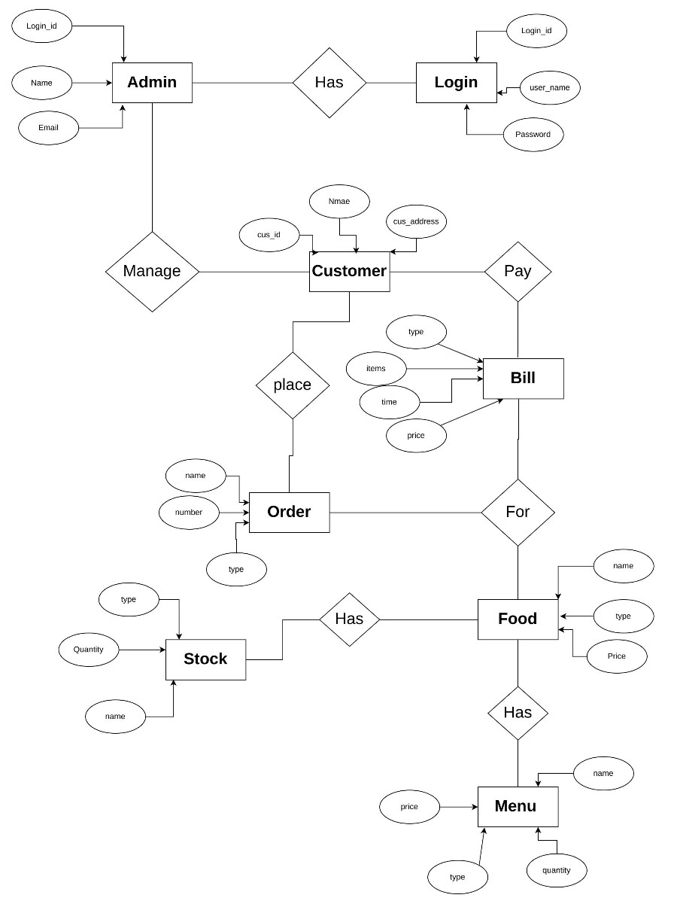

**3.2 CONTEXT LEVEL DFD:-**

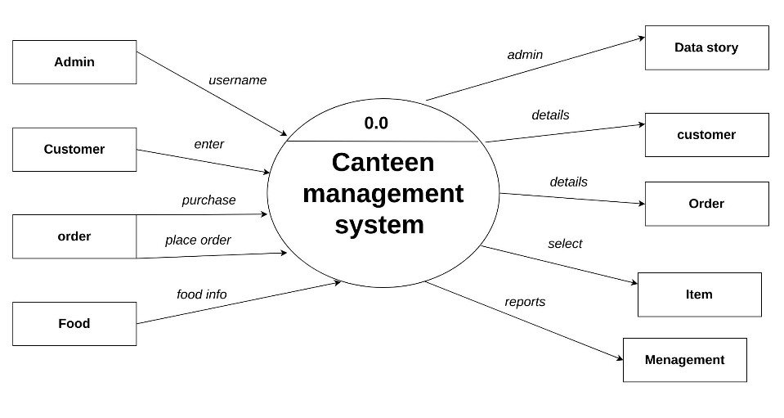

**3.3 FIRST LEVEL DFD**

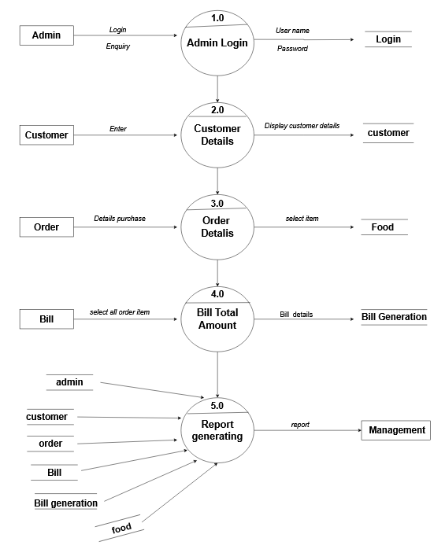

**3.4 FILE DESIGN:**

**Table Admin:-**

|  |  |  |
| --- | --- | --- |
| **Field Name** | **Data Type** | **Constraints** |
| **Id** | **Int** | **Primary key** |
| **Username** | **Varchar** | **-** |
| **Full_Name** | **Varchar** | **-** |
| **Password** | **Varchar** | **-** |

**Table Order:-**

|  |  |  |
| --- | --- | --- |
| **Field Name** | **Data Type** | **Constraints** |
| **Id** | **Int** | **Primary key** |
| **Food** | **varchar** |  |
| **Price** | **varchar** |  |
| **Qty** | **decimal** | **-** |
| **Total** | **varchar** | **-** |
| **Order_data** | **Int** | **-** |
| **Status** | **varchar** | **-** |
| **Customer_name** | **varchar** | **-** |
| **Customer_contact** | **type** | **-** |
| **Customer_email** | **Type** | **-** |
| **Customer_addr** | **Type** | **-** |

**Table category -**

|  |  |  |
| --- | --- | --- |
| **Field Name** | **Data Type** | **Constraints** |
| **Id** | **Int** | **Primary key** |
| **Title** | **varchar** |  |
| **Image_name** | **varchar** | **-** |
| **featured** | **varchar** | **-** |
| **Active** | **varchar** | **-** |

**Table food:-**

|  |  |  |
| --- | --- | --- |
| **Field Name** | **Data Type** | **Constraints** |
| **Id** | **Int** | **Primary key** |
| **Title** | **Varchar** | **-** |
| **description** | **varchar** | **-** |
| **Price** | **decimal** | **-** |
| **Image_name** | **varchar** | **-** |
| **Category_id** | **Int** | **-** |
| **featured** | **varchar** | **-** |
| **Active** | **varchar** | **-** |

**3.5 DATA DICTONARY:-**

|  |  |  |  |  |
| --- | --- | --- | --- | --- |
| **Field** | **Data type**  **And**  **Data size** | **Constraints** | **Table**  **name** | |
| **Id** | **Varchar** | **Primary key** | **Admin** | |
| **username** | **Varchar** | **-** |  | |
| **Full_name** | **Varchar** | **-** |  | |
| **Password** | **Varchar** | **-** |  | |
|  |  |  |  | |
| **Id** | **Integer** | **Primary**  **key** | **order** | |
| **Food** | **Varchar** | **-** |  | |
| **qty** | **Float** | **-** |  | |
| **total** | **Varchar** | **-** |  | |
| **Order_date** | **Integer** | **-** | |  |
| **status** | **varchar** | **-** |  | |
| **Customer_**  **name** | **type** | **-** |  | |
| **Customer_**  **contact** | **type** | **-** |  | |
| **Customer_**  **email** | **type** | **-** |  | |
| **Customer_**  **addr** | **type** | **-** |  | |
|  |  |  |  | |
| **Id** | **Integer** | **Primary key** | **category** | |
| **title** | **varchar** | **-** |  | |
| **Imagename** | **varchar** | **-** |  | |
| **featured** | **varchar** | **-** |  | |
| **active** | **varchar** | **-** |  | |
|  |  |  |  | |
| **id** | **integer** | **primary** | **food** | |
| **title** | **varchar** | **-** |  | |
| **description** | **varchar** | **-** |  | |
| **price** | **decimal** | **-** |  | |
| **imagename** | **varchar** | **-** |  | |
| **Category_id** | **int** | **foreign** |  | |
| **featured** | **varchar** | **-** |  | |
| **active** | **varchar** | **-** |  | |

**4. INPUT FORM**

1. Home page

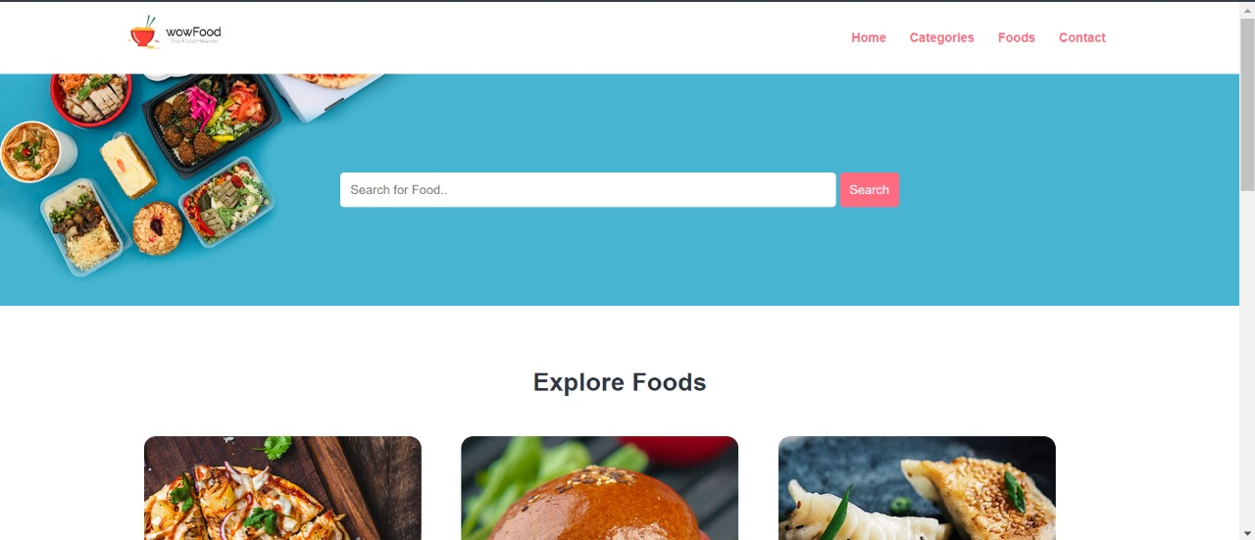

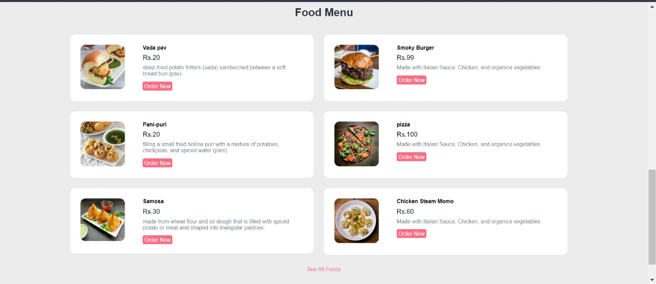

**Admin from**

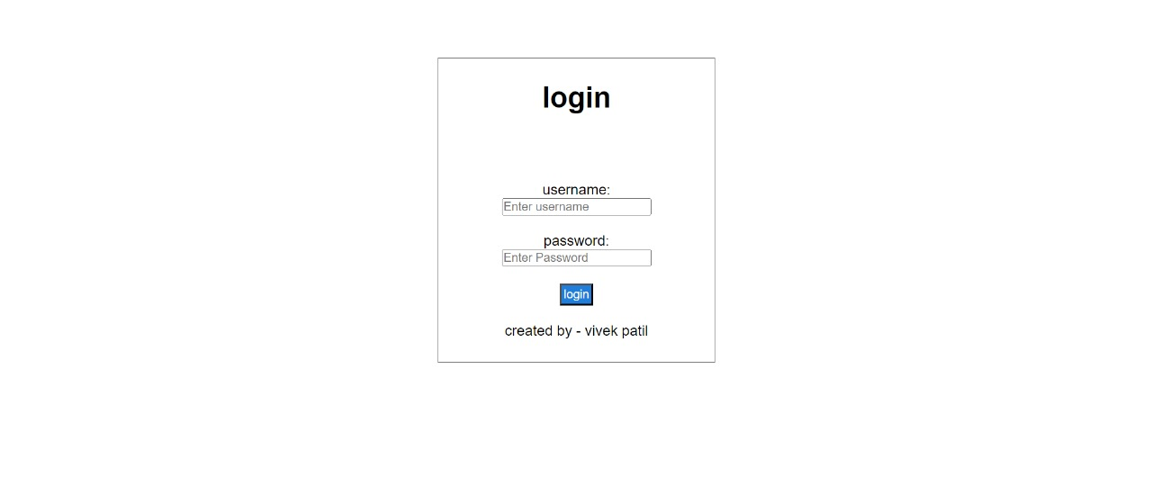

**Admin manage page**

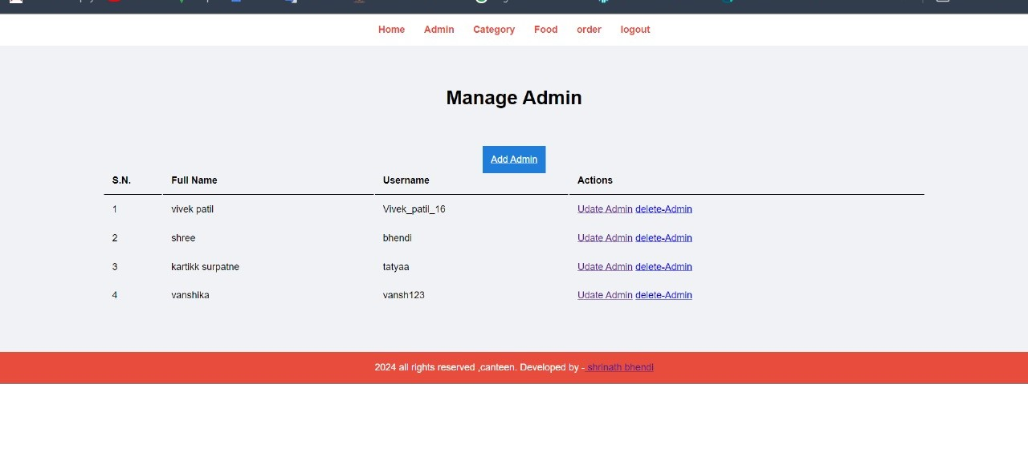

**Manage category**

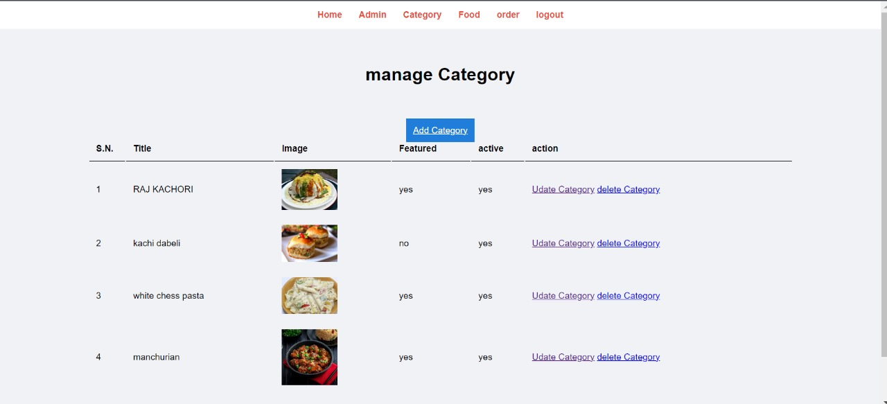

**Category**

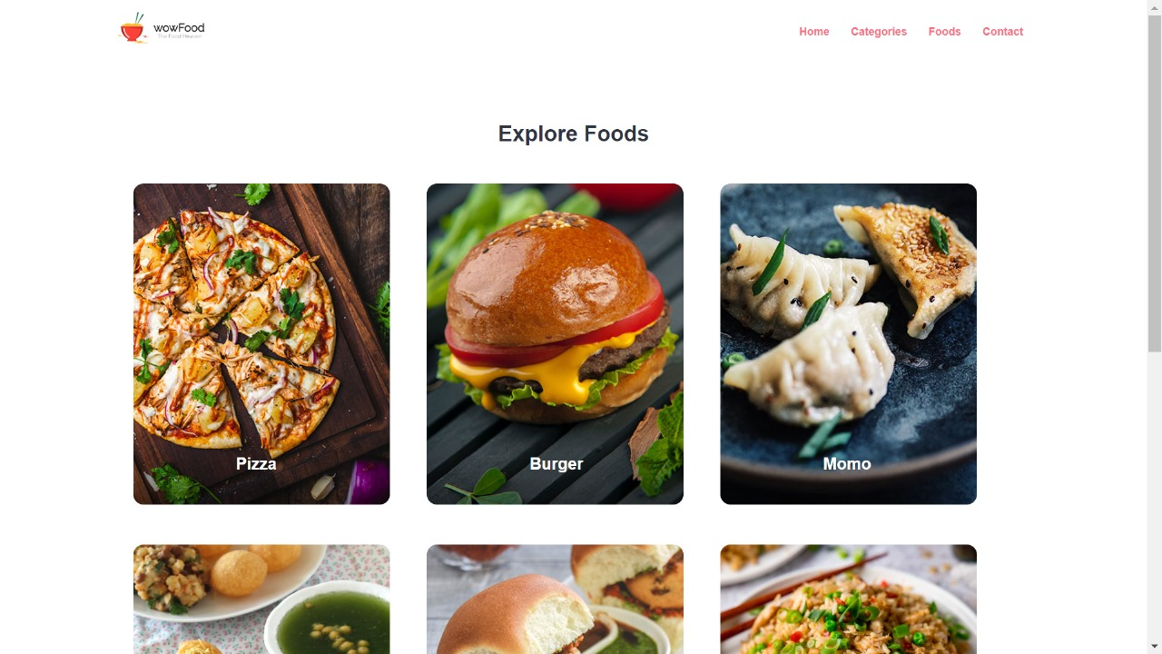

**Order details:**

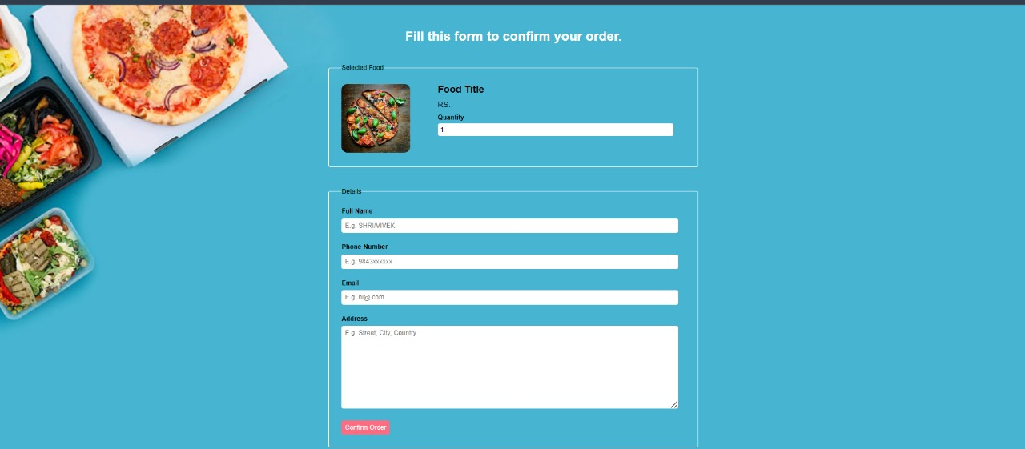

**5 TESTING:-**

Software testing is a critical element of the software quality and represents the ultimate review of specification, design and coding, “testing is the process of executing a program with the intent of coding errors”.

**OBJECTIVES:-**

The objective of testing are as follows:

* To design different tests that uncovers the errors with minimum time and cost.
* To check the software functions appear to be working according to specifications given by user.
* A successful test is one that uncovers with existing system.
* The software delivered interfaces correctly with the existing system.

**BLACK BOX TESTING**

* The end user has concluded black box testing. The user is most concerned with the inputs that the system accepted and the output that if generated.
* Using this approach, it is useful in finding the incorrect or missing function. Interface errors, errors in database, initialization and termination errors. The user has checked every GUI and reports for the error.

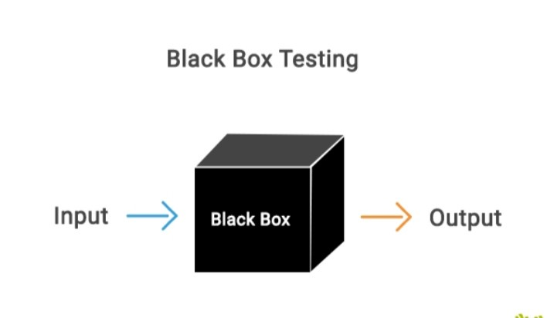

**6.Advantages & Disadvantages Advantages :-**

* inventory control: Canteen management systems can automate inventory, order processing, and billing, which can help with cost efficiency and resource optimization. Real-time insights into stock levels and popular items can also help minimize waste.
* Employee tracking: Canteen management systems can help with employee tracking.
* Time savings: Canteen management systems can help save time and reduce administrative work.
* Accountability: Canteen management systems can help with accountability.

**Disadvantages :-**

* Manual management: Canteen management systems can involve manual management.
* Tedious work: Canteen management systems can involve tedious work.
* naccurate information: Canteen management systems can lead to inaccurate information.

**7.LIMITATION:-**

* The transactions are executed in off-line mode, hence on-line data for canteen, sales capture and modification is not possible.
* Off-line reports of canteen, orders, products cannot be generated due to batch mode execution.
* The existing system only provides text-based interface, which is not as user-friendly as Graphical user Interface.

**8.CONCLUSION:-**

• The development of college Canteen Management System involved many phases. The approach used is a top-down one concentrating on what first then how and moving to successive levels of details.

• The first phase started with a detailed study of the problems and prospects of ordering in Foods.

• This Software is efficient in maintaining customer’s details and can easily perform operations on platform.

**9.FETURE ENHANCEMENTS**

1. In the future we will create more reliable long databases for fetching records. We will also try to provide best services and also online payment methods.

2. In future we will try to updated student profile and also admin profile. Some more interesting features will be added so that students will find it as more useful.

**10.REFERENCES**

1. **Youtube.com**
2. [**www.google.co.in**](http://www.google.co.in)
3. [**https://www.w3schools.org/**](https://www.w3schools.org/)
4. [**https://app.diagrams.net/**](https://app.diagrams.net/)